---VISVESVARAYA TECHNOLOGICAL UNIVERSITY
“JnanaSangama”, Belgaum -590014, Karnataka.



LAB REPORT
on

BIG DATA ANALYTICS
(20CS6PEBDA)

Submitted by

MUSKAN GUPTA (1BM19CS091)

in partial fulfillment for the award of the degree of
BACHELOR OF ENGINEERING
in
COMPUTER SCIENCE AND ENGINEERING



B.M.S. COLLEGE OF ENGINEERING
(Autonomous Institution under VTU)
BENGALURU-560019
May-2022 to July-2022

B. M. S. College of Engineering,
Bull Temple Road, Bangalore 560019
(Affiliated To Visvesvaraya Technological University, Belgaum)
Department of Computer Science and Engineering


CERTIFICATE
This is to certify that the Lab work entitled “BIG DATA ANALYTICS” carried out by MUSKAN GUPTA(1BM19CS091), who is bonafide student of B. M. S. College of Engineering. It is in partial fulfillment for the award of Bachelor of Engineering in Computer Science and Engineering of the Visvesvaraya Technological University, Belgaum during the year 2022. The Lab report has been approved as it satisfies the academic requirements in respect of a BIG DATA ANALYTICS - (20CS6PEBDA)work prescribed for the said degree.

Name of the Lab-Incharge Dr. Jyothi S Nayak
Designation Professor and Head
Department of CSE Department of CSE
BMSCE, Bengaluru BMSCE, Bengaluru
`

Index Sheet
Sl. No. | Experiment Title | Page No.
1 | MongoDB CRUD Demonstration | 4
2 | Cassandra Employee Dtabase | 6
3 | Cassandra Library Database | 8
4 | Hadoop installation | 10
5 | HDFS Commands | 11
6 | Create a Map Reduce program to  a) find average temperature for each year from NCDC data set.  b) find the mean max temperature for every month | 13
7 | For a given Text file, Create a Map Reduce program to sort the content in an alphabetic order  listing only top 10 maximum occurrences of words. | 18
8 | Create a Map Reduce program to demonstrating join operation | 21
9 | Program to print word count on scala shell and print “Hello world” on scala IDE | 27
10 | Using RDD and FlatMap count how many times each word appears in a file and write out a list of  words whose count is strictly greater than 4 using Spark | 28

Course Outcome
CO1 | Apply the concept of NoSQL, Hadoop or Spark for a given task
CO2 | Analyze the Big Data and obtain insight using data analytics mechanisms.
CO3 | Design and implement Big data applications by applying NoSQL, Hadoop or Spark

- MongoDB- CRUD Demonstration
CRUD (CREATE, READ, UPDATE, DELETE) OPERATIONS
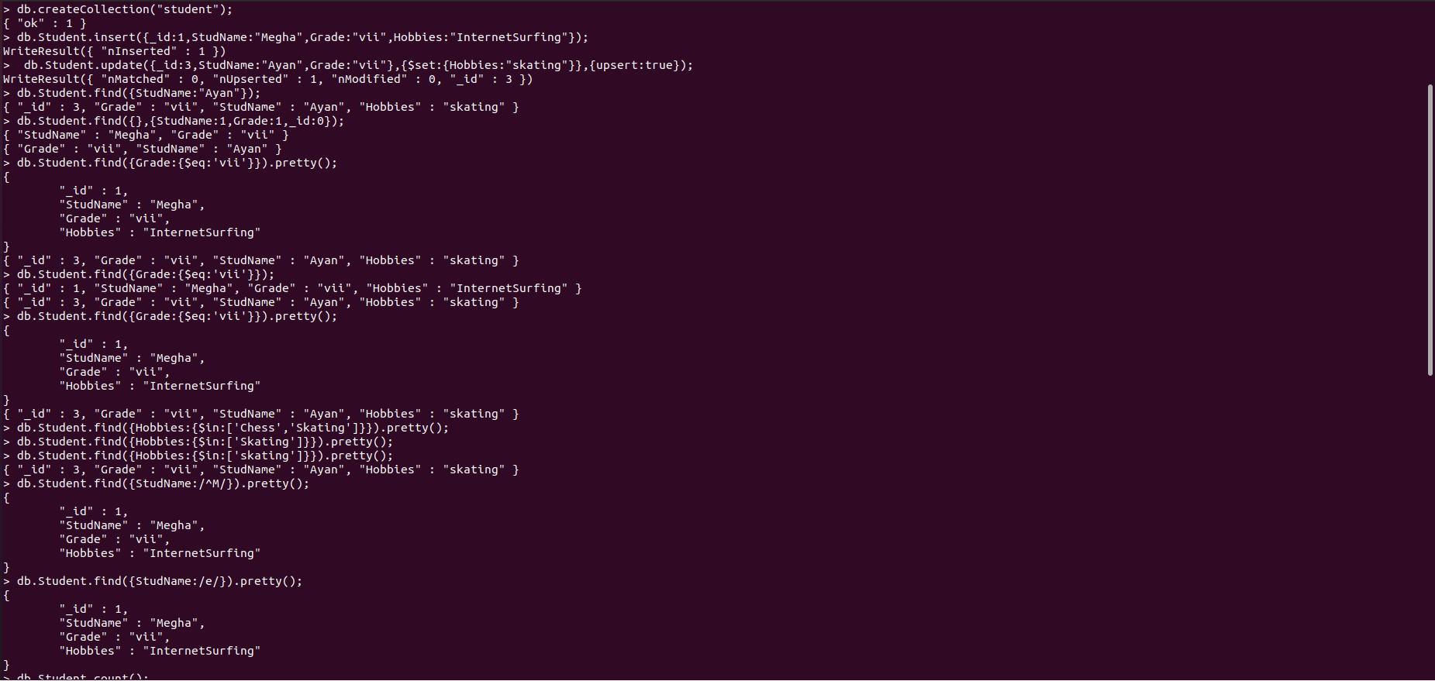

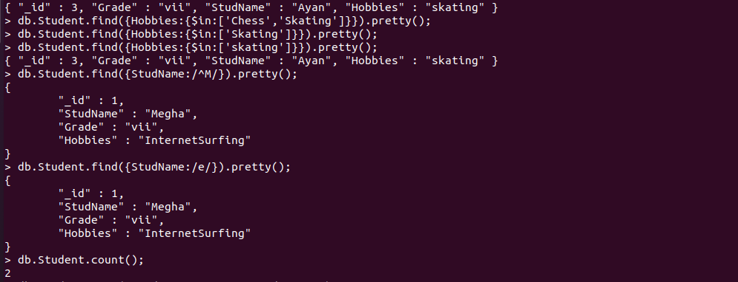
Save Method
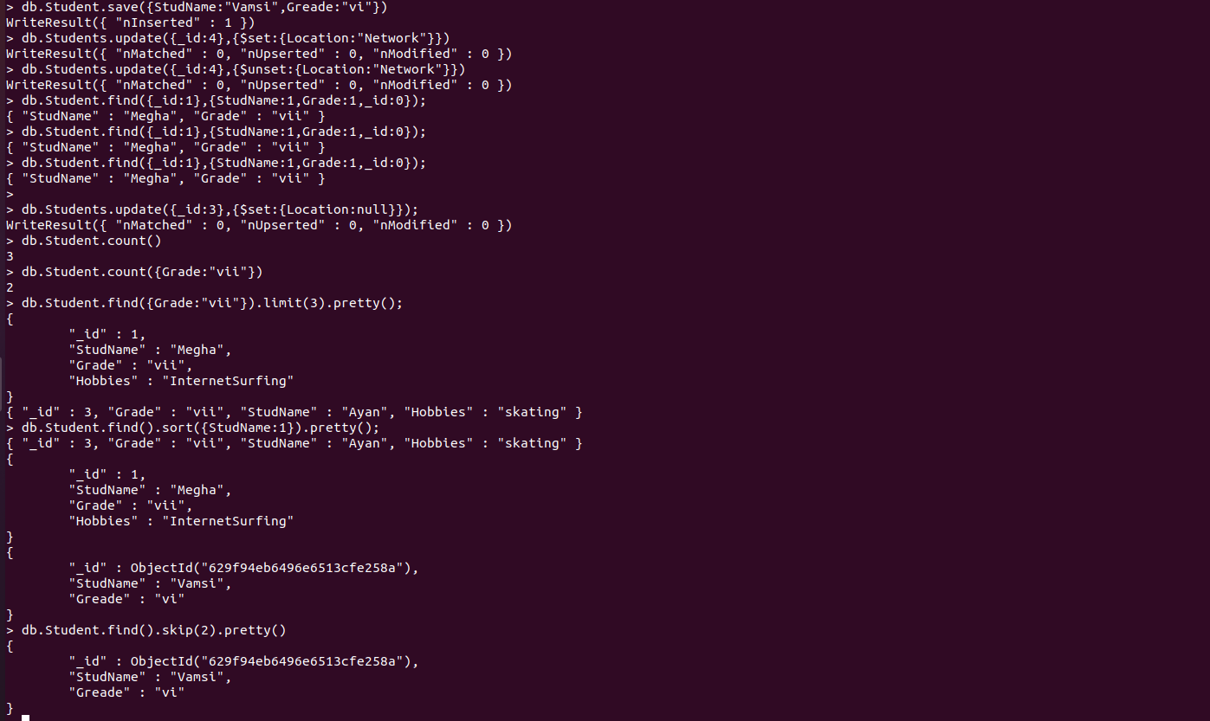

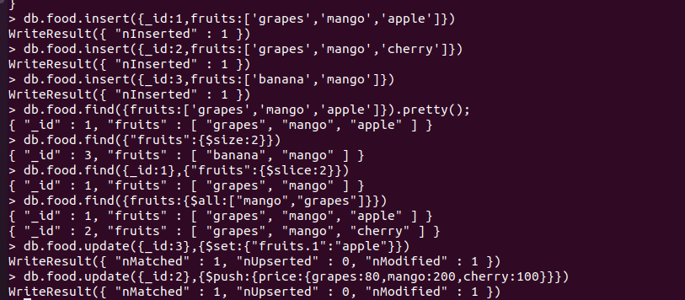

Aggregate Function
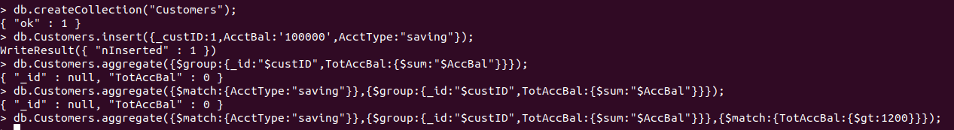

2.Perform the following DB operations using Cassandra.
1.Create a key space by name Employee

2.Create a column family by name Employee-Info with attributes Emp_Id Primary Key, Emp_Name, Designation, Date_of_Joining, Salary, Dept_Name
3.Insert the values into the table in batch

4. Update Employee name and Department of Emp-Id 2
5. Sort the details of Employee records based on salary

6. Alter the schema of the table Employee_Info to add a column Projects which stores a set of Projects done by the corresponding Employee.

7. Update the altered table to add project names.

3. Perform the following DB operations using Cassandra.
1. Create a key space by name Library

2. Create a column family by name Library-Info with attributes Stud_Id Primary Key,
Counter_value of type Counter,
Stud_Name, Book-Name, Book-Id, Date_of_issue

3. Insert the values into the table in batch

4.Display the details of the table created and increase the value of the counter

5. Write a query to show that a student with id 112 has taken a book “BDA” 2 times.

6. Export the created column to a csv file

7. Import a given csv dataset from local file system into Cassandra column family

LAB4

SCREENSHOT OF HADOOP INSTALLATION

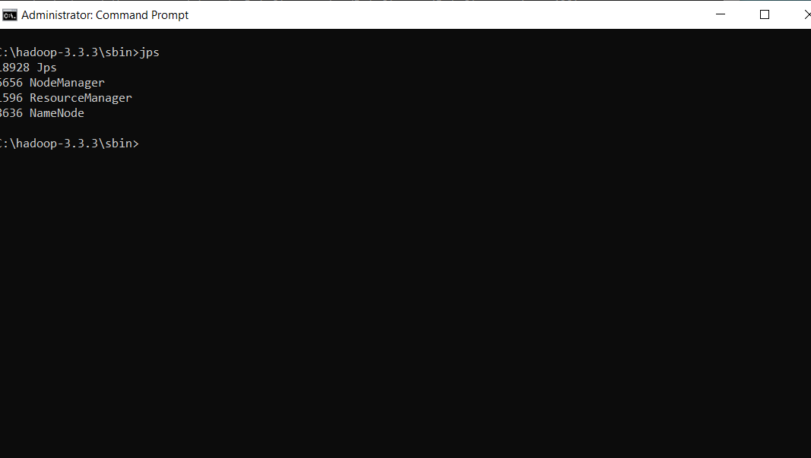

LAB 5
Execution of HDFS Commands for interaction with Hadoop Environment.
LAB 6
For the given file, Create a Map Reduce program to
a) Find the average temperature for each year from the NCDC data set.

// AverageDriver.java package temperature;

import org.apache.hadoop.io.*; import org.apache.hadoop.fs.*; import org.apache.hadoop.mapreduce.*; import org.apache.hadoop.mapreduce.lib.input.FileInputFormat; import org.apache.hadoop.mapreduce.lib.output.FileOutputFormat;

public class AverageDriver
{ public static void main (String[] args) throws Exception
{
if (args.length != 2)
{
System.err.println("Please Enter the input and output parameters");
System.exit(-1);
}
Job job = new Job(); job.setJarByClass(AverageDriver.class); job.setJobName("Max temperature");
FileInputFormat.addInputPath(job,new Path(args[0]));
FileOutputFormat.setOutputPath(job,new Path (args[1]));

job.setMapperClass(AverageMapper.class); job.setReducerClass(AverageReducer.class); job.setOutputKeyClass(Text.class); job.setOutputValueClass(IntWritable.class); System.exit(job.waitForCompletion(true)?0:1);
}
}

//AverageMapper.java package temperature;

import org.apache.hadoop.io.*; import org.apache.hadoop.mapreduce.*; import java.io.IOException;

public class AverageMapper extends Mapper <LongWritable, Text, Text, IntWritable>
{ public static final int MISSING = 9999;

public void map(LongWritable key, Text value, Context context) throws IOException, InterruptedException
{
String line = value.toString(); String year = line.substring(15,19); int temperature; if (line.charAt(87)=='+') temperature = Integer.parseInt(line.substring(88, 92));
else
temperature = Integer.parseInt(line.substring(87, 92)); String quality = line.substring(92, 93); if(temperature != MISSING && quality.matches("[01459]")) context.write(new Text(year),new IntWritable(temperature)); }
}

//AverageReducer.java package temperature;

import org.apache.hadoop.io.IntWritable; import org.apache.hadoop.io.Text; import org.apache.hadoop.mapreduce.*; import java.io.IOException;

public class AverageReducer extends Reducer <Text, IntWritable,Text, IntWritable>
{
public void reduce(Text key, Iterable<IntWritable> values, Context context) throws IOException,InterruptedException
{
int max_temp = 0; int count = 0;
for (IntWritable value : values)
{
max_temp += value.get();
count+=1;
}
context.write(key, new IntWritable(max_temp/count));
}
}
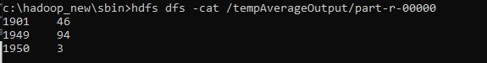

//TempDriver.java package temperatureMax;

import org.apache.hadoop.io.*; import org.apache.hadoop.fs.*; import org.apache.hadoop.mapreduce.*; import org.apache.hadoop.mapreduce.lib.input.FileInputFormat; import org.apache.hadoop.mapreduce.lib.output.FileOutputFormat;

public class TempDriver
{ public static void main (String[] args) throws Exception
{
if (args.length != 2)
{
System.err.println("Please Enter the input and output parameters");
System.exit(-1);
}
Job job = new Job(); job.setJarByClass(TempDriver.class); job.setJobName("Max temperature");
FileInputFormat.addInputPath(job,new Path(args[0]));
FileOutputFormat.setOutputPath(job,new Path (args[1]));

job.setMapperClass(TempMapper.class); job.setReducerClass(TempReducer.class);
job.setOutputKeyClass(Text.class); job.setOutputValueClass(IntWritable.class); System.exit(job.waitForCompletion(true)?0:1);
}
}

//TempMapper.java package temperatureMax;

import org.apache.hadoop.io.*; import org.apache.hadoop.mapreduce.*; import java.io.IOException;

public class TempMapper extends Mapper <LongWritable, Text, Text, IntWritable>
{ public static final int MISSING = 9999;

public void map(LongWritable key, Text value, Context context) throws IOException, InterruptedException
{
String line = value.toString(); String month = line.substring(19,21); int temperature; if (line.charAt(87)=='+') temperature = Integer.parseInt(line.substring(88, 92));
else
temperature = Integer.parseInt(line.substring(87, 92)); String quality = line.substring(92, 93); if(temperature != MISSING && quality.matches("[01459]")) context.write(new Text(month),new IntWritable(temperature)); }
}

//TempReducer.java package temperatureMax;

import org.apache.hadoop.io.*; import org.apache.hadoop.mapreduce.*; import java.io.IOException;

public class TempMapper extends Mapper <LongWritable, Text, Text, IntWritable>
{ public static final int MISSING = 9999;

public void map(LongWritable key, Text value, Context context) throws IOException, InterruptedException
{
String line = value.toString(); String month = line.substring(19,21); int temperature; if (line.charAt(87)=='+') temperature = Integer.parseInt(line.substring(88, 92));
else
temperature = Integer.parseInt(line.substring(87, 92)); String quality = line.substring(92, 93); if(temperature != MISSING && quality.matches("[01459]")) context.write(new Text(month),new IntWritable(temperature));
}
}

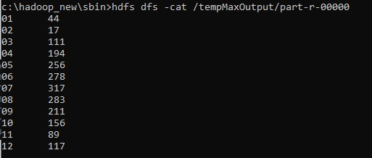

LAB7
For a given Text file, create a Map Reduce program to sort the content in an alphabetic order listing only top ‘n’ maximum occurrence of words.

// TopN.java package sortWords;

import org.apache.hadoop.conf.Configuration; import org.apache.hadoop.fs.Path; import org.apache.hadoop.io.IntWritable; import org.apache.hadoop.io.Text; import org.apache.hadoop.mapreduce.Job; import org.apache.hadoop.mapreduce.Mapper; import org.apache.hadoop.mapreduce.Reducer; import org.apache.hadoop.mapreduce.lib.input.FileInputFormat; import org.apache.hadoop.mapreduce.lib.output.FileOutputFormat; import org.apache.hadoop.util.GenericOptionsParser; import utils.MiscUtils;

import java.io.IOException; import java.util.*;

public class TopN {

public static void main(String[] args) throws Exception {
Configuration conf = new Configuration();
String[] otherArgs = new GenericOptionsParser(conf, args).getRemainingArgs(); if (otherArgs.length != 2) {
System.err.println("Usage: TopN <in> <out>");
System.exit(2);
}
Job job = Job.getInstance(conf); job.setJobName("Top N"); job.setJarByClass(TopN.class); job.setMapperClass(TopNMapper.class); //job.setCombinerClass(TopNReducer.class); job.setReducerClass(TopNReducer.class); job.setOutputKeyClass(Text.class); job.setOutputValueClass(IntWritable.class);
FileInputFormat.addInputPath(job, new Path(otherArgs[0]));
FileOutputFormat.setOutputPath(job, new Path(otherArgs[1]));
System.exit(job.waitForCompletion(true) ? 0 : 1);
}

/**
* The mapper reads one line at the time, splits it into an array of single words and emits every * word to the reducers with the value of 1.
*/
public static class TopNMapper extends Mapper<Object, Text, Text, IntWritable> {

private final static IntWritable one = new IntWritable(1); private Text word = new Text();
private String tokens = "[_|$#<>\\^=\\[\\]\\*/\\\\,;,.\\-:()?!\"']";

@Override
public void map(Object key, Text value, Context context) throws IOException,
InterruptedException {
String cleanLine = value.toString().toLowerCase().replaceAll(tokens, " "); StringTokenizer itr = new StringTokenizer(cleanLine); while (itr.hasMoreTokens()) {
word.set(itr.nextToken().trim()); context.write(word, one);
}
}
}

/**
* The reducer retrieves every word and puts it into a Map: if the word already exists in the * map, increments its value, otherwise sets it to 1.
*/
public static class TopNReducer extends Reducer<Text, IntWritable, Text, IntWritable> {

private Map<Text, IntWritable> countMap = new HashMap<>();

@Override
public void reduce(Text key, Iterable<IntWritable> values, Context context) throws IOException, InterruptedException {

// computes the number of occurrences of a single word int sum = 0; for (IntWritable val : values) { sum += val.get();
}
// puts the number of occurrences of this word into the map.
// We need to create another Text object because the Text instance
// we receive is the same for all the words countMap.put(new Text(key), new IntWritable(sum));
}
@Override
protected void cleanup(Context context) throws IOException, InterruptedException {

Map<Text, IntWritable> sortedMap = MiscUtils.sortByValues(countMap);

int counter = 0; for (Text key : sortedMap.keySet()) { if (counter++ == 3) { break;
}
context.write(key, sortedMap.get(key));
}
}
}

/**
* The combiner retrieves every word and puts it into a Map: if the word already exists in the * map, increments its value, otherwise sets it to 1.
*/
public static class TopNCombiner extends Reducer<Text, IntWritable, Text, IntWritable> {

@Override
public void reduce(Text key, Iterable<IntWritable> values, Context context) throws IOException, InterruptedException {

// computes the number of occurrences of a single word int sum = 0; for (IntWritable val : values) { sum += val.get();
}
context.write(key, new IntWritable(sum));
}
}
}

// MiscUtils.java package utils;

import java.util.*;

public class MiscUtils {

/**
sorts the map by values. Taken from:
http://javarevisited.blogspot.it/2012/12/how-to-sort-hashmap-java-by-key-and-value.html
*/
public static <K extends Comparable, V extends Comparable> Map<K, V> sortByValues(Map<K, V> map) {
List<Map.Entry<K, V>> entries = new LinkedList<Map.Entry<K, V>>(map.entrySet());

Collections.sort(entries, new Comparator<Map.Entry<K, V>>() {

@Override public int compare(Map.Entry<K, V> o1, Map.Entry<K, V> o2) { return o2.getValue().compareTo(o1.getValue());
}
});

//LinkedHashMap will keep the keys in the order they are inserted
//which is currently sorted on natural ordering
Map<K, V> sortedMap = new LinkedHashMap<K, V>();
for (Map.Entry<K, V> entry : entries) {
sortedMap.put(entry.getKey(), entry.getValue());
}
return sortedMap;
}
} 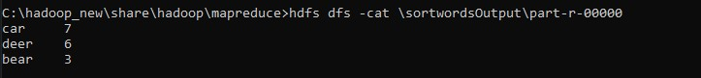
LAB 8
Create a Hadoop Map Reduce program to combine information from the users file along with Information from the posts file by using the concept of join and display user_id, Reputation and Score.

// JoinDriver.java import org.apache.hadoop.conf.Configured; import org.apache.hadoop.fs.Path; import org.apache.hadoop.io.Text; import org.apache.hadoop.mapred.*; import org.apache.hadoop.mapred.lib.MultipleInputs; import org.apache.hadoop.util.*;

public class JoinDriver extends Configured implements Tool {

public static class KeyPartitioner implements Partitioner<TextPair, Text> {
@Override
public void configure(JobConf job) {}

@Override
public int getPartition(TextPair key, Text value, int numPartitions) { return (key.getFirst().hashCode() & Integer.MAX_VALUE) % numPartitions;
}
}

@Override public int run(String[] args) throws Exception { if (args.length != 3) {
System.out.println("Usage: <Department Emp Strength input>
<Department Name input> <output>");
return -1;
}

JobConf conf = new JobConf(getConf(), getClass()); conf.setJobName("Join 'Department Emp Strength input' with 'Department Name input'");

Path AInputPath = new Path(args[0]);
Path BInputPath = new Path(args[1]);
Path outputPath = new Path(args[2]);

MultipleInputs.addInputPath(conf, AInputPath, TextInputFormat.class,
Posts.class);
MultipleInputs.addInputPath(conf, BInputPath, TextInputFormat.class,
User.class);

FileOutputFormat.setOutputPath(conf, outputPath);

conf.setPartitionerClass(KeyPartitioner.class);
conf.setOutputValueGroupingComparator(TextPair.FirstComparator.class);

conf.setMapOutputKeyClass(TextPair.class);

conf.setReducerClass(JoinReducer.class);

conf.setOutputKeyClass(Text.class);

JobClient.runJob(conf);

return 0;
}

public static void main(String[] args) throws Exception {

int exitCode = ToolRunner.run(new JoinDriver(), args);
System.exit(exitCode);
}
}

// JoinReducer.java import java.io.IOException; import java.util.Iterator;

import org.apache.hadoop.io.Text; import org.apache.hadoop.mapred.*;

public class JoinReducer extends MapReduceBase implements Reducer<TextPair, Text, Text, Text> {

@Override
public void reduce (TextPair key, Iterator<Text> values, OutputCollector<Text, Text> output, Reporter reporter)
throws IOException
{

Text nodeId = new Text(values.next()); while (values.hasNext()) {
Text node = values.next();
Text outValue = new Text(nodeId.toString() + "\t\t" + node.toString()); output.collect(key.getFirst(), outValue);
}
}
}

// User.java import java.io.IOException; import java.util.Iterator; import org.apache.hadoop.conf.Configuration; import org.apache.hadoop.fs.FSDataInputStream; import org.apache.hadoop.fs.FSDataOutputStream; import org.apache.hadoop.fs.FileSystem; import org.apache.hadoop.fs.Path; import org.apache.hadoop.io.LongWritable; import org.apache.hadoop.io.Text; import org.apache.hadoop.mapred.*;

import org.apache.hadoop.io.IntWritable;

public class User extends MapReduceBase implements Mapper<LongWritable, Text, TextPair, Text> {

@Override
public void map(LongWritable key, Text value, OutputCollector<TextPair, Text> output, Reporter reporter)
throws IOException
{

String valueString = value.toString();
String[] SingleNodeData = valueString.split("\t");
output.collect(new TextPair(SingleNodeData[0], "1"), new
Text(SingleNodeData[1]));
}
}

//Posts.java import java.io.IOException;

import org.apache.hadoop.io.*; import org.apache.hadoop.mapred.*;

public class Posts extends MapReduceBase implements Mapper<LongWritable, Text, TextPair, Text> {

@Override
public void map(LongWritable key, Text value, OutputCollector<TextPair, Text> output, Reporter reporter)
throws IOException
{
String valueString = value.toString();
String[] SingleNodeData = valueString.split("\t"); output.collect(new TextPair(SingleNodeData[3], "0"), new
Text(SingleNodeData[9]));
}
}

// TextPair.java import java.io.*;

import org.apache.hadoop.io.*;
public class TextPair implements WritableComparable<TextPair> {

private Text first; private Text second;

public TextPair() { set(new Text(), new Text());
}

public TextPair(String first, String second) { set(new Text(first), new Text(second));
}

public TextPair(Text first, Text second) { set(first, second);
}

public void set(Text first, Text second) { this.first = first; this.second = second;
}

public Text getFirst() { return first;
}

public Text getSecond() { return second;
}

@Override
public void write(DataOutput out) throws IOException { first.write(out); second.write(out);
}

@Override public void readFields(DataInput in) throws IOException { first.readFields(in); second.readFields(in);
}

@Override public int hashCode() { return first.hashCode() * 163 + second.hashCode();
}

@Override public boolean equals(Object o) { if (o instanceof TextPair) { TextPair tp = (TextPair) o; return first.equals(tp.first) && second.equals(tp.second);
} return false;
}

@Override public String toString() { return first + "\t" + second;
}

@Override
public int compareTo(TextPair tp) { int cmp = first.compareTo(tp.first); if (cmp != 0) { return cmp;
}
return second.compareTo(tp.second);
}
// ^^ TextPair

// vv TextPairComparator public static class Comparator extends WritableComparator {

private static final Text.Comparator TEXT_COMPARATOR = new Text.Comparator();

public Comparator() { super(TextPair.class);
}

@Override public int compare(byte[] b1, int s1, int l1, byte[] b2, int s2, int l2) {
try {
int firstL1 = WritableUtils.decodeVIntSize(b1[s1]) + readVInt(b1, s1); int firstL2 = WritableUtils.decodeVIntSize(b2[s2]) + readVInt(b2, s2); int cmp = TEXT_COMPARATOR.compare(b1, s1, firstL1, b2, s2, firstL2); if (cmp != 0) { return cmp;
}
return TEXT_COMPARATOR.compare(b1, s1 + firstL1, l1 - firstL1,
b2, s2 + firstL2, l2 - firstL2);
} catch (IOException e) { throw new IllegalArgumentException(e);
}
}
}

static {
WritableComparator.define(TextPair.class, new Comparator());
}
public static class FirstComparator extends WritableComparator {

private static final Text.Comparator TEXT_COMPARATOR = new Text.Comparator();

public FirstComparator() { super(TextPair.class);
}

@Override public int compare(byte[] b1, int s1, int l1, byte[] b2, int s2, int l2) {
try {
int firstL1 = WritableUtils.decodeVIntSize(b1[s1]) + readVInt(b1, s1); int firstL2 = WritableUtils.decodeVIntSize(b2[s2]) + readVInt(b2, s2); return TEXT_COMPARATOR.compare(b1, s1, firstL1, b2, s2, firstL2);
} catch (IOException e) { throw new IllegalArgumentException(e);
}
}

@Override
public int compare(WritableComparable a, WritableComparable b) { if (a instanceof TextPair && b instanceof TextPair) { return ((TextPair) a).first.compareTo(((TextPair) b).first);
}
return super.compare(a, b);
}
}
}

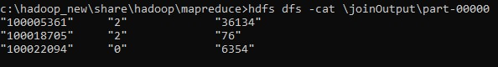

\

LAB 9

Program to print word count on scala shell and print “Hello world” on scala IDE

scala> println("Hello World!");
Hello World!

val data=sc.textFile("sparkdata.txt")
data.collect;
val splitdata = data.flatMap(line => line.split(" "));
splitdata.collect;
val mapdata = splitdata.map(word => (word,1));
mapdata.collect;
val reducedata = mapdata.reduceByKey(_+_);
reducedata.collect;

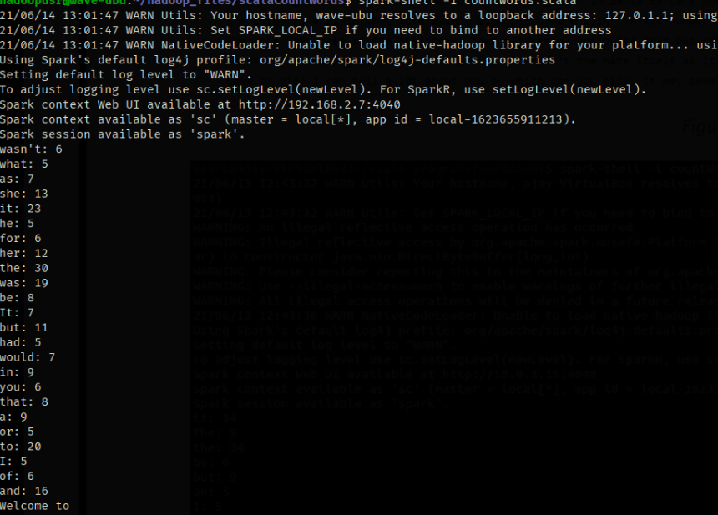

LAB 10

Using RDD and Flat Map count how many times each word appears in a file and write out a list of words whose count is strictly greater than 4 using Spark

